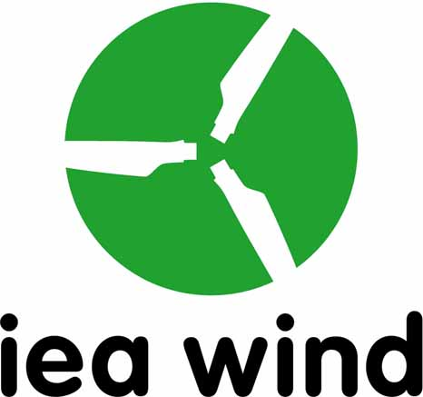

International Energy Agency (IEA)
Implementing Agreement for Co-operation in the Research and Development of Wind Energy Systems (IEA Wind TCP)

Task XXXIX Proposal
Quiet Wind Turbine Technology

18 October 2018

[John Mc Cann SEAI Ireland, Franck Bertagnolio DTU, Michaela Herr DLR, Birger Luhmann, Stuttgart Univ., Xavier Falourd, Gavin Irvine, Ion Acoustics]

Scope
The purpose of the proposed IEA Wind Task is to coordinate international research on quiet wind turbine technology and in related technology fields. Technology to be considered within this Task will not solely be wind turbine technology but also related technology and practices, that may facilitate its deployment, in related fields including acoustics and noise regulations. The work packages proposed below are intended to meet this scope.

Introduction
More renewable power generation systems were deployed than thermal power generators for the ﬁrst time in 2013. The rapid rise to the dominant position of these developing technologies in new power sector investments reﬂects the policy priority of decarbonising global electricity systems.

Societal acceptance of new technologies can be key to their ultimate successful adoption, the utility of a technology may not automatically guarantee this if its deployment aﬀects those in society who do not accrue direct beneﬁts from it. Emergent societal acceptance issues are commonplace for new technologies as they reach the mass deployment stage, particularly where this is rapid, and these issues must be satisfactorily resolved for the technologies that are ultimately to be successful.

Particular public concerns have been raised on the impacts of wind turbine noise in some jurisdictions. While the sources of excessive noise for the majority of society will be from other man-made technologies, it is important to ensure that those who live in the proximity of wind turbines will not be subjected to excessive noise from these.

Regulation has an important role in the technology development process. Good regula¬tion will anticipate progressive and societally beneﬁcial technology advances and facili¬tate their adoption. It is important that regulations are based upon objective analysis and that guidelines are put in place to allow policy makers focus the debate on to the right topics.

A survey of national regulations dealing with noise control for wind turbines reveals that, while there are speciﬁc international standards for noise measurement, there are a diversity of national noise limits and deﬁned approaches to the overall wind turbine noise assessment process. This diversity indicates that there may be room for convergence towards a common framework underpinning national guidance.

From an industry perspective, the wind turbine supply market is international and not local. The diversity of local noise regulations may bring unwarranted compliance costs and confound progressive technical advances to develop wind turbines with lower noise impact.

This proposal is for a new IEA Wind RD&D research collaboration to accelerate the development and deployment of quiet wind turbine technology. The collaboration will carry out its work in a series of focussed work packages.

Objectives and Expected Results
The objective of the proposed Task, is to convene an international expert panel to: (i) exchange learning, (ii) identify and report upon best practice in the analysis, measurement and assessment wind turbine sound that may support deployment of quiet wind turbine technologies; (iii) recommend a survey instrument for assessing noise annoyance and develop communications materials to assist in addressing community concerns about wind turbine noise.

Of course, there is a considerable body of work already completed; the broader work on wind turbine noise is considerable and growing. On amplitude modulation specifically, work has been completed by organisations in several countries and across many disciplines. These organisations include NREL, DTU/Risø, the Institute of Acoustics in the UK and several eﬀorts in Canada, among many others.

This task will build consensus through interdisciplinary cooperation, involving insofar as possible engineers and scientists, environmental scientists and acousticians, psychologists, physiologists, audiologists, sociologists and policy makers. Initial work will structure discussion between disciplines, groups and countries. An aim is to understand and recognise the value in the work completed across disciplines. Conﬂicting or incomplete ideas can be identiﬁed for further research work as part of the task. Such a process will lead to robust, scientiﬁc, widely accepted and transparent metrics for wind turbine noise. It is in this spirit that we make this proposal.

It is worth highlighting that noise is not only or even primarily an engineering problem. The engineer quantiﬁes noise source mechanisms and characteristics and develops instrumentation, data analysis tools, models and procedures for measuring and predicting wind turbine noise. Eﬀective environmental noise metrics for wind turbines, however, require psycho-acoustic testing and an understanding of the physiological response of the human ear, among other things. Individual technologies have individual peculiarities to their noise characteristics and methods and simplifying assumptions developed for existing technologies may have to be reassessed and adapted for the noise characteristics of new technologies. For example, consideration of amplitude modulation is not commonplace for existing technologies but speciﬁc consideration of this may be required for wind turbines.
For this reason, two technical work streams are proposed, understanding the problem of wind turbine noise from the perspective of both the physics of the noise generation and the eﬀect of turbine noise on human receptors.

In the end, the aim is well-informed agreement. This will happen through engaged participation.

Approach and Methodologies
In addition to a management work package, an interdisciplinary education/guidance work package (WP 1) is proposed; the scientific investigative work will be carried ouWP 2 in turn feed into a knowledge base and an evolving recommended practice (WP 3). The evolving recommended practice will form the basis of discussions during WP1. The Sustainable Energy Authority of Ireland will initially lead all work packages, supported by a contracted expert and guided by the expertise of the task participants. Priorities will be ﬁnalised after consultation with potential participants.

Draft Work Plan

Work Package 0: Management and Coordination – The Task will be managed within this work package. The Operating Agent (OA) will ensure that the technical objectives and deliverables are achieved and will facilitate ongoing technical communication among the Work Package Leaders and the IEA Wind ExCo. The OA will contract for expert support to provide insight, advice and technical input and editing in the field of acoustics.

One of the ﬁrst jobs of this WP will be to establish the Task web site with both public and private access for the Task. This website will facilitate discussion and collaboration between the Task partners as well as provide public information, e.g. papers. The WP will help deﬁne standard data and reporting formats for the Task. The WP will use appropriate project management procedures. Dissemination and regular liaison with the IEA Wind ExCo will be an integral part of this work package.

The WP primarily focuses on the communication of essential information between the participants on the achievement of the technical objectives according to the time schedule of section 5.

Deliverables
- 5 x meetings, i.e. every 6 months for 36 months (M6, M12, M18, M24, M36)
- D0.1: Task 39 web site (M6)
- D0.2: First annual progress report (M12)
- D0.3: Second annual progress report (M24)
- D0.4: Final report (M36)

Work Package 1: Interdisciplinary Education and Guidance
Period: M1-M36

How wind turbine noise aﬀects people and how best to monitor exposure; these questions are not yet fully answered. Much work has been conducted at international level across disciplines including engineering, physiology, psychology and sociology. This work package will support interdisciplinary discussion. The aim is for a consensus with robust, scientiﬁc, widely accepted and transparent metrics for wind turbine noise. The following activities will be engaged with in WP1 in the first term of Task 39:

State of the Art Report: this report will present the current leading thinking and best practice on both quiet wind turbine technology and the processes supporting its adoption. Individual section contributions will be solicited from relevant experts both within and outside Task 39. The individual contributions to these workshops will be collated into a state of the art report;

Catalogue/Database of International Wind Turbine Noise Regulations: this will collate the most recent noise regulations worldwide, characterising these by both the type and level of noise limits and associated controlled acoustic characteristics. Once the database is populated, explanatory charts and graphics will be developed;

Considerations when Developing Wind Turbine Noise Guidance: Informed by the survey of international regulations, a guidance document will be produced aimed at assisting policymakers and regulators engaged with developing national regulations;

Task 39 Fact Sheets: Along with the above guidance, explanatory Fact Sheets will be developed on key technical aspects of quiet wind turbine technology and wind turbine noise. These Fact Sheets will aim to explain acoustics concepts to the layperson in accessible language. The following are the proposed topics for the first six (6) Task 39 Fact Sheets:
- Amplitude Modulation
- Low Frequency noise
- Infrasound
- Tonal Noise
- Measurement technology
- Noise indices and measurement

Tasks:
- Task 1.1: State of the Art Report
- Task 1.2: Catalogue/Database of International Wind Turbine Noise Regulations
- Task 1.3: Considerations for Developing Wind Turbine Noise Guidance
- Task 1.4: Fact Sheets
Deliverables:
- D1.1: Table of contents State of the Art Report (M6)
- D1.2: Template for catalogue/database of international wind turbine noise regulation (M6)
- D1.3: Quiet Wind Turbine Technology, State of the Art Report, (First copy) (M24)
- D1.4: Quiet Wind Turbine Technology, State of the Art Report (Final version) (M36)
- D1.5 Recommended Practice: Considerations for Developing Wind Turbine Noise Guidance (M30)
- D1.6: Fact Sheets (M12, M18, M24 M36)

Work Package 2: Physics of Noise
Period: M12 to M36

Workpackage 2 will focus upon the methods that are applied to analysing, measuring, quantifying and qualifying, the generation, propagation and sensing of wind turbine noise. In the first term of Task 39 WP2 will focus on modelling of WTN emission, propagation and immission; categorisation and classification of quiet wind turbine technologies; and, quantification and qualification of the key parameters of wind turbine noise
Noise modelling: This activity will include benchmarking of noise models (Collaboration with MEXNEXT), Propagation studies (subject to appropriate participation), and, later, farm level and wake modelling (Collaboration with WAKEBENCH)
Quiet Wind Turbine Technologies: This activity will include categorisation and classification of QWTT, to provide a framework for modelling and testing, identify the sources and pathways addressed and also noise emission mitigation/optimisation (compromises e.g. soundscape customisation; aerodynamic v.s tonal noise)
Quantification/Qualification: This activity will encompass physical effects and pathways, field experiments and field measurements and will include:
Consideration of physical effects & pathways - High Frequency Noise, Low Frequency Noise, Infrasound, Tonal Noise, vibration (& Vibration induced noise);
Large scale funded field experiments (TREMAC, WEA Akzeptanz etc.)
- Physical metrics
- Qualitative assessment methods (survey instruments);
Field measurements
- Data and findings from compliance monitoring
- Field experiments by practicing acousticians
- Results from field trials of quiet wind turbine technologies

Tasks:
- Task 2.1: Setting-up of the benchmark platform
- Task 2.2: Definition of the baseline test-case and 1st test matrix
- Task 2.3: Deliver results for 1st simulation round.
- Task 2.4: Defining 2nd test matrix taking into account discrepancies, failures, etc, of the first simulation round.
- Task 2.4: Deliver results for 2nd simulation round.
- Task 2.5: Design of serrations for a NACA63018 aerofoil
- Task 2.6: Test matrix for wind tunnel test and benchmarking
- Task 2.7: Wind tunnel test of the NACA63018 aerofoil and acoustic measurements
- Task 2.8: Benchmarking of the serration noise codes with the wind tunnel data
Deliverables:
- D2.1: Initial comparison report (M18)
- D2.2: Second comparison report. (M24)
- D2.3: Serrations test report (M30)
- D2.4: Serrations noise codes benchmarking report (M36)

Work Package 3: Psychology of Noise
Period: M12 to M36

This work package will deal with the subjective factors that affect the human perception of sound as being noise and the triggers for annoyance. These may include, not only the qualities of the sound that may be heard, but also exogenous factors, such as communication during the permitting, construction and operational phases of a wind farm project.

Psychoacoustics:
- Field-based psychoacoustic surveys (Collaboration with Task 28)
  - Assessing annoyance – survey instrument design
- Laboratory based psychoacoustics (subject to participant)
- Communicating noise concepts:
  - Public engagement
  - Design of communications media
  - Auralisation
Tasks:
- Task 3.1: Develop noise annoyance survey instrument for use in pyschoacoustic field studies/longitudinal surveys
- Task 3.2: Develop communication templates and graphics for communicating noise concepts

Deliverables:
- D3.1: Noise annoyance survey instrument (M20)
- D3.2: Communication templates and graphics. (M30)

Time Schedule with Key Dates
Figure 1 Work Plan Chronogram

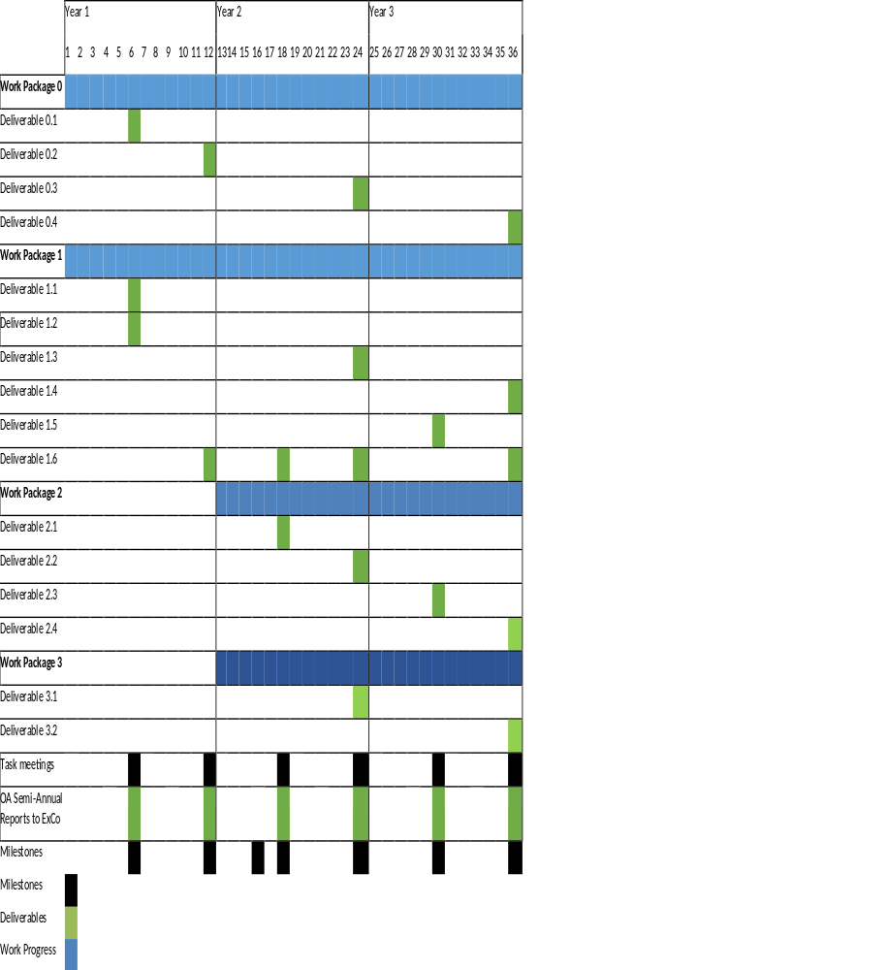

Reports, Deliverables, and Dissemination of Results
Table 1 Planned Deliverables and Schedule
No. | Deliverable | Contributors | Month Due
D0.0 | Semi-Annual Progress Reports to ExCo | OA | 6,12,18, 24, 36
D0.1 | Web-Site |  | 6
D1.1 | Table of contents State of the Art Report | OA | 6
D1.2 | Template for catalogue/database of international wind turbine noise regulation | OA | 12
D1.3 | Quiet Wind Turbine Technology, State of the Art Report, (First copy) | OA and others | 24
D1.4 | Quiet Wind Turbine Technology, State of the Art Report (Final version) | OA | 36
D1.5 | Recommended Practice: Considerations for Developing Wind Turbine Noise Guidance | OA and others | 16
D1.6 | Fact Sheets | OA and others | 12, 18, 24, 36
D2.1 | Initial comparison report | DTU, DLR | 18
D2.2 | Second comparison report | DTU, DLR | 24
D2.3 | Serrations test report (M30 | DTU | 30
D2.4 | Serrations noise codes benchmarking report | DTU | 36
D3.1 | Noise annoyance survey instrument | MSH OA | 20
D3.2 | Communication templates and graphics. | MSH OA | 30
D-04 | Final Report | OA, DTU, DLR, MSH | 36

Methods of Review and Evaluation of the Work Progress
Table 2 Milestones and Schedule

No. | Milestone | Contributors | Month Due
M-1 | Revised WorkPlan Approved | OA, All | 6
M-2 | Catalogue/Database of Noise Regulations Hosted Online | OA, All | 12
M-3 | Draft Recommended Practice: Considerations in developing WTN Guidance | OA, All | 16
M-4 | State of the Art Report, First Copy for Review by ExCo | OA,All | 18
M-5 | Benchmarking of noise codes completed | DTU, DLR | 24
M-6 | Noise Annoyance Survey Instrument and Communications Templates and Graphics Completed | MSH, OA | 30
M-7 | Serrations Testing and Report Completed | DTU | 36
M-8 | State of the Art Report Final Version Completed | OA, All | 36
M-9 | Final Report Completed | OA, All | 36

Obligations and Responsibilities
This Task requires collaboration among all Participants as well as contributing technical work that is conducted independently. The general obligations of the Operating Agent and the Participants are described below. The data and products developed through this Task will be available equally to all participants. Data and products of this Task will not be available externally until completion of the Task or by agreement of the Participants. New entrants will be encouraged throughout the Task and will be obligated to contribute to the cost-share for the year in which the Task is joined. Participants who wish to withdraw from this Task after it begins will be obligated to contribute their share of the cost-share for the year in which they wish to withdraw.

Operating Agent
In addition to the responsibilities enumerated in Article 4 of the IEA Wind Agreement the Operating Agent shall:
- Act as the single point of contact for the Task with the IEA
- Prepare a detailed Task Work Plan in cooperation with the other Participants and submit for approval by the Executive Committee and update the plan annually
- Be responsible for organizing meetings with representatives designated by Participants, including:
  - Annual Technical Exchange Meetings to report on ongoing wind turbine noise research
  - Semi-annual webinar on each relevant activity. Activities will be defined with scope statements and an activity leader
  - Discussion forums for each activity that will be organized and maintained by the activity leaders
- Develop recommended practice concerning considerations in developing wind turbine noise guidance. Develop an online catalogue/database of current national noise regulations, populating this with member country contributions
- Develop recommendations for research needed to increase market acceptance
- Maintain a website of documents and summary of activities
- Be responsible for the performance of the Task and report annually to the Executive Committee on the progress and the results of the work performed under the Work Plan
- Provide to the Executive Committee, within six months after completion of all work defined in the Work Plan, a final report summarizing the findings of the Task for its approval and transmittal to the Agency.

The responsibilities of the Operating Agent relate to the international cooperation in the Task XXXIX. The Operating Agent shall not be liable for the national efforts of the Participants even if the national efforts are in relation to the Task XXXIX.

Participants
In addition to any obligations listed in the IEA Wind Agreement, the following obligations and responsibilities will be adhered to by the Participants of the Task:
- Each Participant shall bear its own cost for the scientific work, including travel expenses.
- The host country/sponsor shall bear the costs of workshops and meetings of experts.
- The total costs of the Operating Agent shall be borne jointly and in equal shares by the Participants.
- Each Participant shall transfer to the Operating Agent its annual share of the costs in accordance with a time schedule to be determined by the Participants, acting under the direction of the Executive Committee.
- Each Participant shall submit presentation materials and reports presented at the Task meetings to the Operating Agent for posting on the Task website, the format of which shall be agreed upon by the Participants.
- Each Participant will participate in editing and review of Task XXXIX articles, presentations, technical documents, and the Final Report.

In addition to the activities described in the Work Packages in Section 4, each participating country/sponsor is conducting related work. The planned effort from each participating country/sponsor will be estimated and documented in Table 4 at the Task kick-off meeting. The column “Task XXXIX effort” indicates the effort taken specifically for this Task while the column “related effort” indicates the effort for related work that will partly support this task. The Task is expected to officially begin on Month/Date/Year to be determined and will conclude three years after.

Table 3. Planned effort from each Participant
Country | Participant |  | Subject | National effort | Related effort | Total effort
 |  |  | Work package | Person- month | Person- month | Person- month
Ireland | SEAI/Operating Agent |  | WP 1 & 3
Denmark | Danish Technical |  | WP 1 & 2
Germany | DLR |  | WP 2
 | MSH/ML |  | WP 3
Total

Funding
This Task will be both “cost shared” and “task-shared” in that the costs of the Operating Agent shall be borne jointly and in equal shares by the Participants. The funding principles are summarized as follows:
- Each Participant shall bear their own costs for carrying out the scientific work, including reporting and travel expenses.
- The host shall bear the costs of workshops and meetings convened in conjunction with this Task.
- Each participating country’s intended resource allocations for the projected three years will be determined at the outset of the Task (see Table 4 above).
- Each participant shall transfer to the Operating Agent their annual share of the costs in accordance with a time schedule to be determined by the Participants, acting under the direction of the Executive Committee.

Until such time that a replacement operating agent comes forward, the proposed Operating Agent is the Sustainable Energy Authority of Ireland and it will accept the rights and powers, and will carry out the obligations and functions of the Operating Agent as provided in the Agreement. SEAI will contract, through an RfQ, for expert support to it in the role of Operating Agent.

Budget Plan
The estimated total costs of the Operating Agent for coordination, management and reporting will be Euro 55,143 per year and a total of Euro 159,429 over three year project duration, as shown below in Table 5.
Notes:
1. The operating agent, SEAI, will not charge for its employee’s time in managing the Task, but solely for contracted expert technical support. SEAI has contracted with Ion Acoustics for expert support for the first period of the task;
2. At a Task 39 meeting on September 27th the operating agent, SEAI, has given Task 39 participants notice of SEAI’s intention to resign from that role and has asked other Task participants to consider taking up the role. Franck Bertagnolio of DTU has expressed an interest in becoming operating agent. SEAI will continue to provide operating agent support up in a transition period of up to 6 months.

Table 5. Projected estimated Operating Agent Costs
Expense Item | Description | Estimated Cost  (Euros per year) | Estimated Cost  (Euros Total)
Management & Technical Support | Sub-contracted technical support. | 55,143 | 159,429
Travel | 3 meetings (plenary + ExCo) | 7,000 | 21,000
Administrative and Miscellaneous | Website, etc. | 2,000 | 6,000
Total |  | 64,143 | 186,429

The costs of the Operating Agent will be divided equally by the Participants and will be invoiced once a year. If eight IEA Wind member countries ultimately join the Task, then the estimated annual invoice would be Euro 8,018 per Participant.

Management of Task
The Operating Agent is responsible for overall Task management and reporting. The management structure will be designed to conduct the work packages as described in Section 4 of this document according to the planned work scope and budget. The OA will coordinate with the participants to 1) define the scope and estimated labor for each Participant’s contribution for inclusion in the work plan, 2) establish a communication method and procedure for collaboration to conduct the work, 3) monitor progress through semi-annual reporting, and 4) conduct plenary meetings at approximately 6 month intervals at which progress is evaluated by all participants. Each Participant will support the Task according to the list of planned and agreed country/sponsor participant contributions within the defined work scope.

The OA will arrange the in-person meetings once a year in coordination with the meeting host. As part of each meeting, Participants will be expected to give a presentation on the most recent national/sponsor activities that support the work of Task XXXIX and other topical items within the work scope. Meeting notes will be distributed to all participants after each of the plenary meetings.

In order to facilitate the required collaboration, web-based meetings will be conducted as needed throughout the project duration.

E-mail will be used as the primary method of communication between meetings using a master mailing list that will be used for organizing meetings, distributing information, and as a platform for discussions. The OA will keep the mailing list up to date.

A website will be created for Task XXXIX and web pages will be maintained and updated throughout the project duration for data archive, transfer, and dissemination of information to the Participants and to the public.

The semi-annual Task status reports that are prepared for the Executive Committee will also be distributed to the participants. All of this information will be available on the IEA Wind members-only website.

Organisation
The Task will, for the time being, be centrally managed by the Sustainable Energy Authority of Ireland. Work package leaders may be assigned in accordance with the approach and methodologies detailed in Section 4 and the Task Work Plan that will be developed following ExCo approval of the Task.

The Task Operating Agent is proposed to be: John Mc Cann, SEAI, until a replacement Operating Agent comes forward.

Expert support is being provided to SEAI in the role of Task Operating Agent by: Gavin Irvine, Ion Acoustics U.K.

Information and Intellectual Property
- Executive Committee's Powers. The publication, distribution, handling, protection and ownership of information and intellectual property arising from activities conducted under this Annex, and rules and procedures related thereto shall be determined by the Executive Committee, acting by unanimity, in conformity with the Agreement.
- Right to Publish. Subject only to copyright restrictions, the Annex Participants shall have the right to publish all information provided to or arising from this Task except proprietary information.
- Proprietary Information. The Operating Agent and the Annex Participants shall take all necessary measures in accordance with this paragraph, the laws of their respective countries and international law to protect proprietary information provided to or arising from the Task. For the purposes of this Annex, proprietary information shall mean information of a confidential nature, such as trade secrets and know-how (for example computer programmes, design procedures and techniques, chemical composition of materials, or manufacturing methods, processes, or treatments) which is appropriately marked, provided such information:
- Is not generally known or publicly available from other sources;
- Has not previously been made available by the owner to others without obligation concerning its confidentiality; and
- Is not already in the possession of the recipient Participant without obligation concerning its confidentiality.
It shall be the responsibility of each Participant supplying proprietary information, and of the Operating Agent for arising proprietary information, to identify the information as such and to ensure that it is appropriately marked.

- Use of Confidential Information. If a Participant has access to confidential information which would be useful to the Operating Agent in conducting studies, assessments, analyses, or evaluations, such information may be communicated to the Operating Agent but shall not become part of reports or other documentation, nor be communicated to the other Participants except as may be agreed between the Operating Agent and the Participant which supplies such information.
- Acquisition of Information for the Task. Each Participant shall inform the other Participants and the Operating Agent of the existence of information that can be of value for the Task, but which is not freely available, and the Participant shall endeavour to make the information available to the Task under reasonable conditions.
- Reports on Work Performed under the Task. Each Participant and the Operating Agent shall provide reports on all work performed under the Task and the results thereof, including studies, assessments, analyses, evaluations and other documentation, but excluding proprietary information, to the other Participants. Reports summarizing the work performed and the results thereof shall be prepared by the Operating Agent and forwarded to the Executive Committee.
- Arising Inventions. Inventions made or conceived in the course of or under the Task (arising inventions) shall be identified promptly and reported to the Operating Agent. Information regarding inventions on which patent protection is to be obtained shall not be published or publicly disclosed by the Operating Agent or the Participants until a patent application has been filed in any of the countries of the Participants, provided, however, that this restriction on publication or disclosure shall not extend beyond six months from the date of reporting the invention. It shall be the responsibility of the Operating Agent to appropriately mark Task reports that disclose inventions that have not been appropriately protected by the filing of a patent application.
- Licensing of Arising Patents. Each Participant shall have the sole right to license its government and nationals of its country designated by it to use patents and patent applications arising from the Task in its country, and the Participants shall notify the other Participants of the terms of such licences. Royalties obtained by such licensing shall be the property of the Participant.
- Copyright. The Operating Agent may take appropriate measures necessary to protect copyrightable material generated under the Task. Copyrights obtained shall be held for the benefit of the Annex Participants, provided however, that the Annex Participants may reproduce and distribute such material, but shall not publish it with a view to profit, except as otherwise directed by the Executive Committee, acting by unanimity.
- Inventors and Authors. Each Annex Participant will, without prejudice to any rights of inventors or authors under its national laws, take necessary steps to provide the co-operation from its inventors and authors required to carry out the provisions of this paragraph. Each Annex Participant will assume the responsibility to pay awards or compensation required to be paid to its employees according to the law of its country.

List of Potential Participants
Table Countries and Organisations Participating in Task __

Country | Institution(s)
Denmark | DTU
Germany | DLR  MSH/MLTU
Ireland | SEAI, RPS, TCD

